CSC263 Database Systems

Midterm Examination
Part II – Hands On

NAME: ___________Steven Moody_________ Score: __________________/50

The hands-on part of the exam is based on a COMPANY database.

A COMPANY Database Application

This COMPANY database keeps track of a company’s employees and their dependents, departments, and projects. Suppose that after the requirements collection and analysis phase, the database designers provide the following description, i.e., the part of the company that will be represented in the database.

- The company is organized into departments. Each department has a unique name, a unique number, and a particular employee who manages the department. We keep track of the start date when that employee began managing the department. A department may have several locations.
- A department controls a number of projects, each of which has a unique name, a unique number, and a single location.
- We store each employee’s name, Social Security number, address, salary, sex (gender), and birth date. An employee is assigned to one department, but may work on several projects, which are not necessarily controlled by the same department. We keep track of the current number of hours per week that an employee works on each project. We also keep track of the direct supervisor of each employee (who is another employee).
- We want to keep track of the dependents of each employee for insurance purposes. We keep each dependent’s first name, sex, birth date, and relationship to the employee.
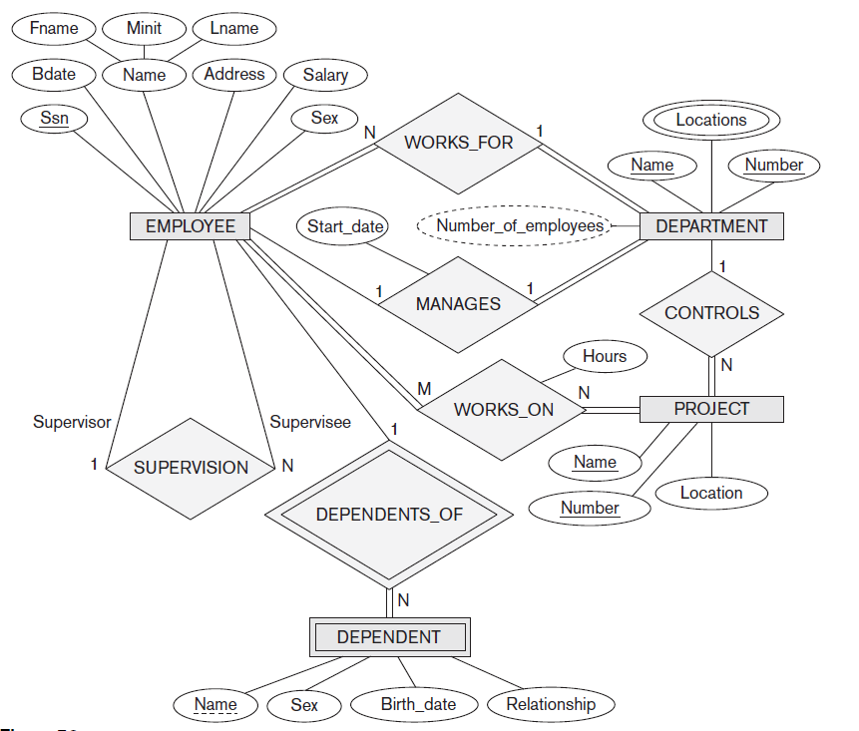

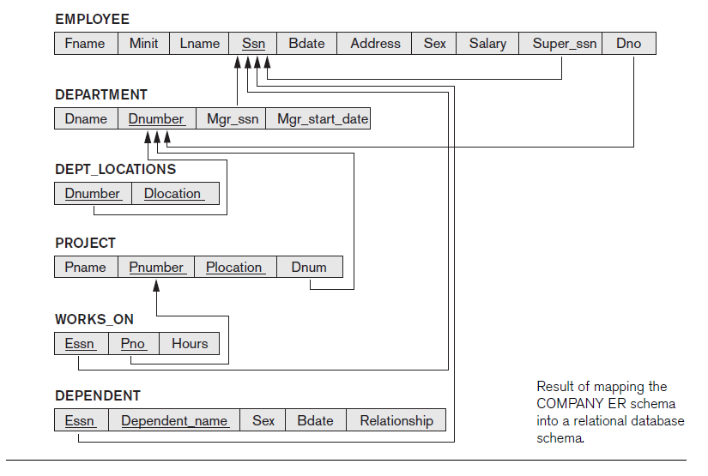

Step 1. In your MySQL account on the department server, create and populate the database using the scripts give.

Step 2. Work out the following queries and take screen shots of the results by your queries.

- Display all employee names and salary using the following heading.

First Name Last Name Yearly Salary
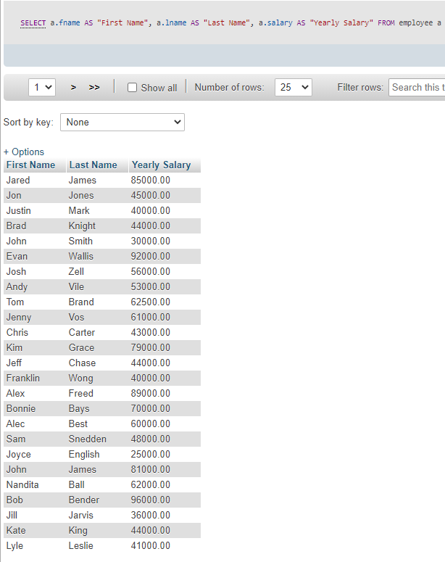

- Display the departments using the following heading and in ascending order of their department number.
Department Name Department Number
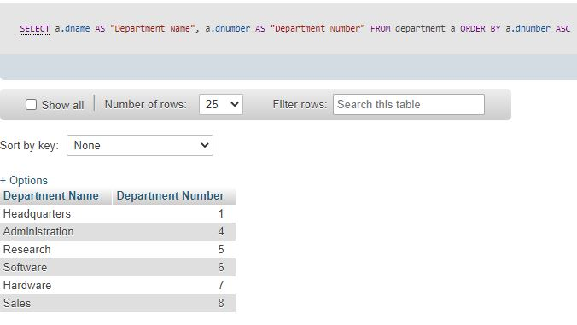

- Display those projects that are located in Houston, using the following heading.

Project Name Project Number Location

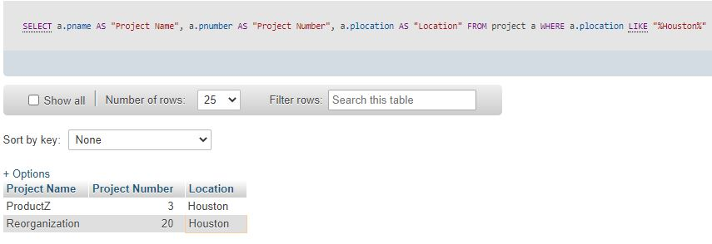

- Display the employees who make yearly salary of $50000 or higher, using the following heading.

First Name Last Name Yearly Salary

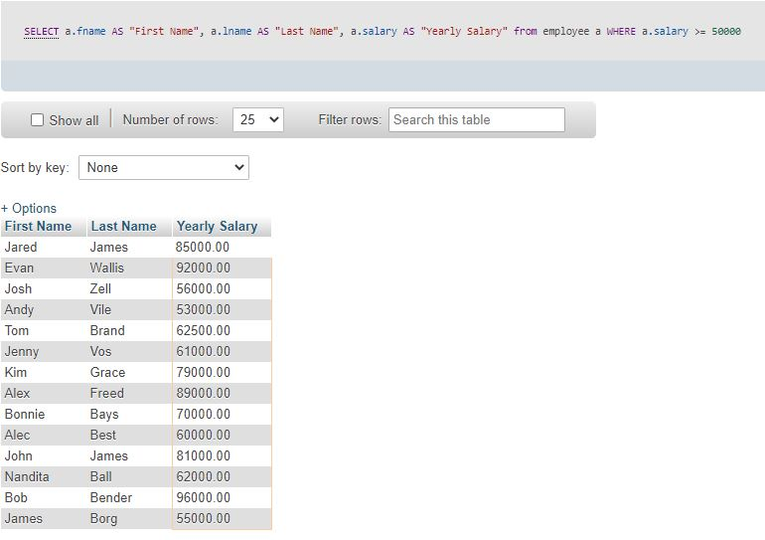

- Display, by descending order of their salaries, the employees who make yearly salary of $50000 or higher, using the following heading,

First Name Last Name Yearly Salary
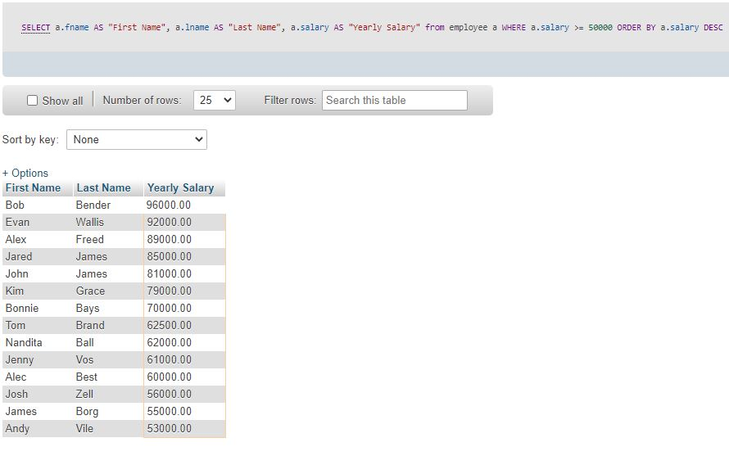

- Using the following heading, display those employees who have 444444400 as their supervisor.

First Name Last Name Gender Salary
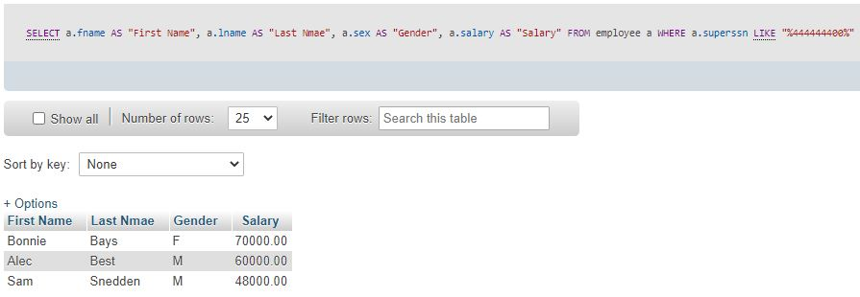

- Using the following heading, display the project numbers and the hours worked on each project by those two mployees whose SSN is 123456789 and 333445555.

Employee SSN Project Hours Worked
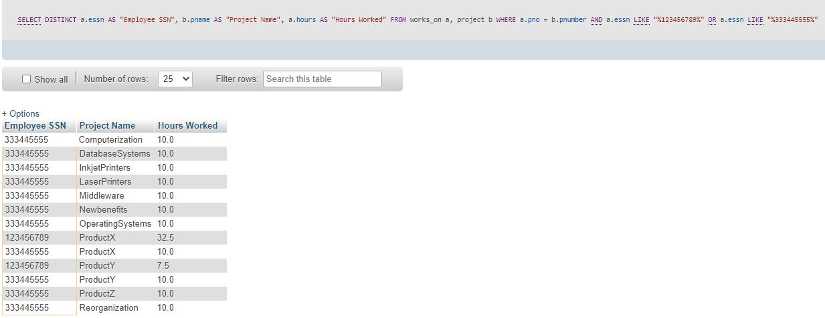

- Calculate and display the lowest, highest and average salaries in the company, using the following heading.

Lowest Salary Highest Salary Average Salary

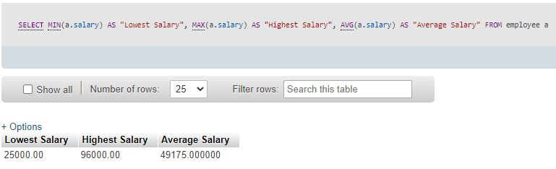

- Calculate the total salary of all employees make in the company.

Total Salary
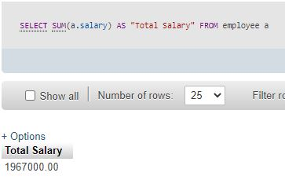

- Calculate and display the total number of hours the employee 123456789 worked on all projects he/she is working on.

Total Hours
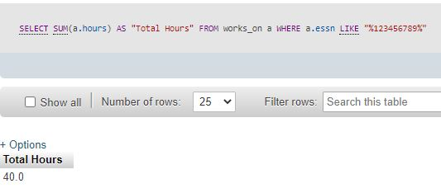

- Calculate and display the total number of hours project 62 has been worked on, using the following long heading.

Total hours worked on project 62
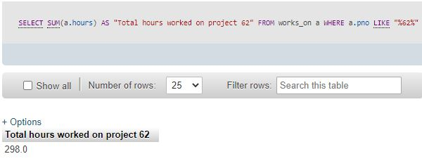

- From the largest to the smallest departments, display departments (by their numbers) and the total number of employees in each department

Department Number Number of Employees
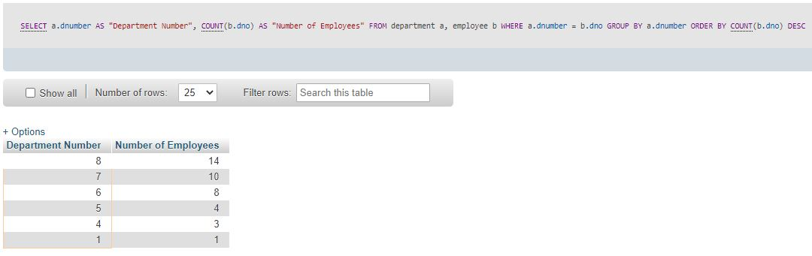
- By employee number, list those employees who have more than 2 dependents.

Employee Number Number of Dependents
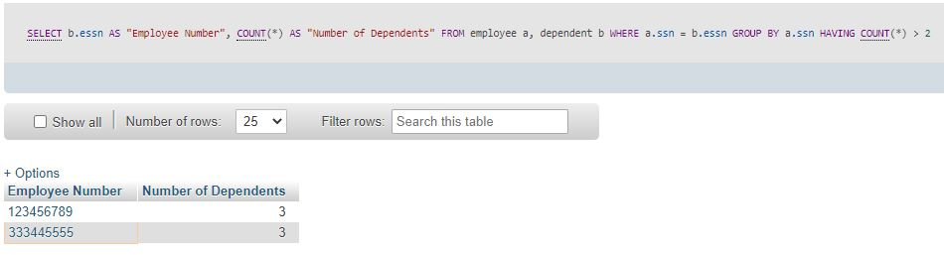

- List those departments that have more than 3 employees, using the following headings.

Department Number Number of Employees

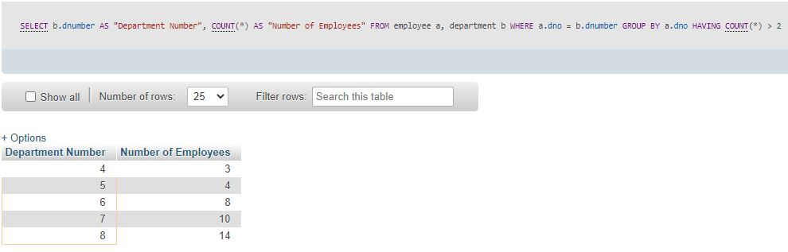

- Write a SQL query to find out which employee is working the most number of projects.

